75. Based on lines 12-20, fill in the following table. (2m)

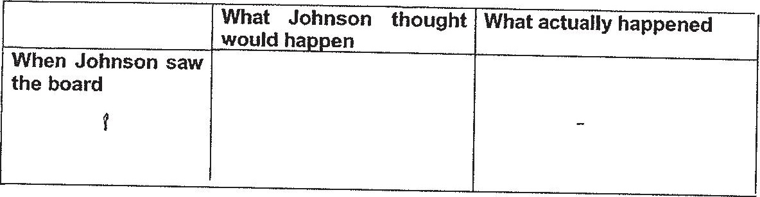

76.LOok at the table below. What do the words in the left column refer to in the passage?  
Write your answers in the column on the tight. (8m)

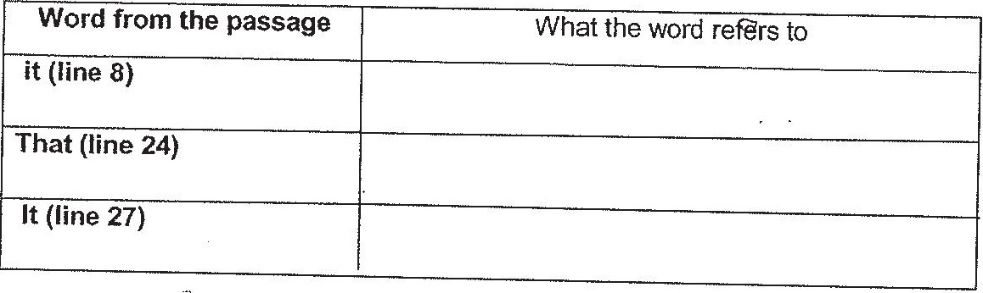

(7? Write 1, 2 and 3 in the blanks below to indicate the order in which the events occurred in  
the story. [1m]

____________Johnson was attacked by the spider.

(EMPTy)__Jonnson turned around and saw the spider.

_________ Johnson tried to look for a way out of the barn.